Thomas Telford Multi Academy Trust



Staff Code of Conduct

Redhill Primary Academy
and
Thomas Telford Primary Free School

 | 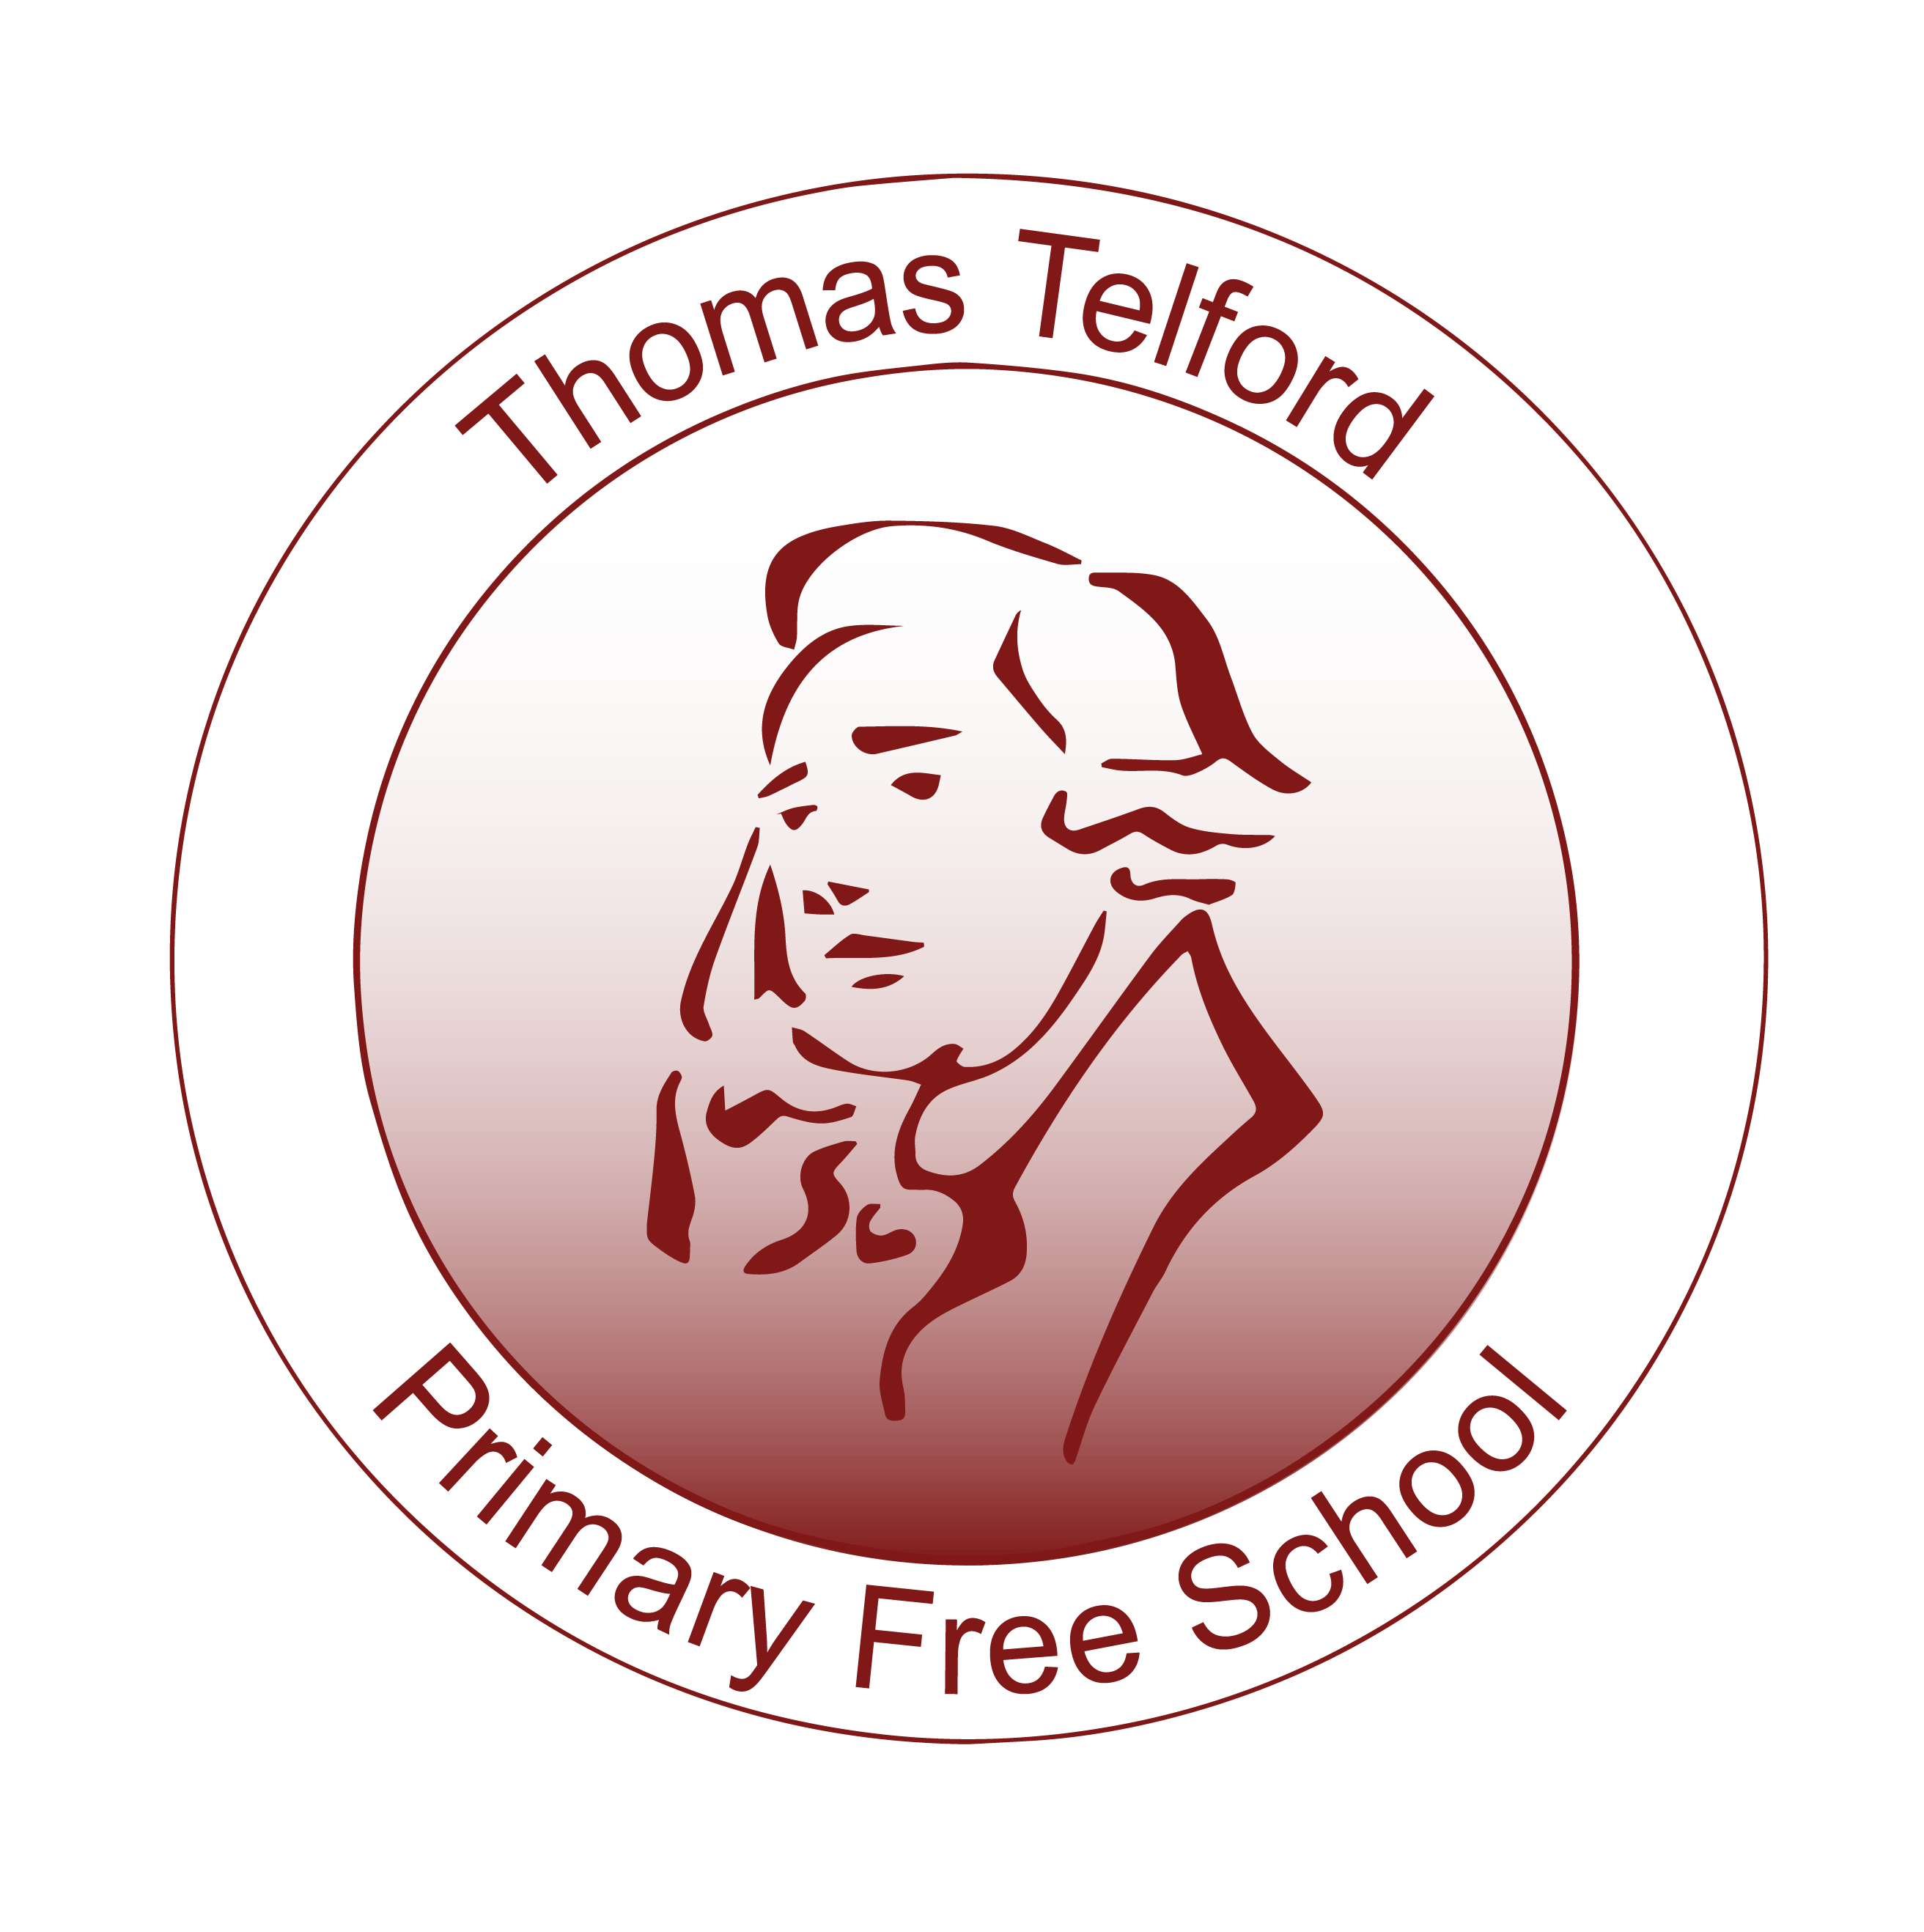
Signed
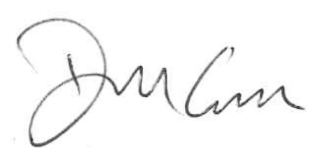

Mr Dara Carroll
Chair of Governors
September 2025

Overarching Code of Conduct for Staff

Introduction

This document outlines the school’s expectation in relation to employee conduct and outlines the school’s responsibility to the employee. This document mainly refers conduct expected in the workplace but may also cover conducted when representing the schools e.g. whilst at training, attending work related functions or activities on social media that may affect the reputation of the schools.

It should also be used in conjunction with other relevant policies and standards such as professional standards, child protection and safeguarding policies, behaviour policy, contract of employment/written statement of particulars, to name but a few.

Given the nature of this establishment, this document should also be a guide to assist in ensuring children’s and employees safety. It therefore explains the responsibilities the schools have towards employees and pupils.

This code should be reviewed regularly by governors and reissued to staff after the review.

2. Duty of Care

The schools have a duty of care to the pupils within it and also to all its employees. This duty should be at the heart of all employee and employer practice.

Pupils – employees within the schools have a duty to keep pupils safe, promote their welfare and protect them from harm, and have a child centred approach to safeguarding as outlined in “Keeping Children Safe in Education” 2025. Given the position of trust this places employee in, employees are expected to take reasonable steps to ensure pupils/children’s safety and well being. Please refer to the Child Protection & Safeguarding in Schools Policies that the schools have adopted.

Employees – employers should provide a safe working environment and appropriate guidance regarding safer working practices. They should also ensure that employees are treated fairly and reasonably in all circumstances. Employees will be informed of all relevant policies as part of their induction. Where a new or revised policy is adopted, the schools will ensure each employee has access to it.

In addition, each employee has a personal duty to take care of themselves and anyone else who may be affected by their actions or failings.

Employees should:

- Understand the responsibilities of their role and the sanctions should these not be followed.
- Act and be seen to act in the pupil’s best interest.
- Act in a way to protect the school’s reputation.
- Avoid conduct which could lead the schools to question motivation and intentions.
- Act in line with the school’s policy and procedure.
- Take responsibility for the learning environment in the classroom and beyond, keeping it tidy and clutter free at all times.
- Take responsibility for their own actions and behaviour.
- Speak up promptly about any concerns they have or anything they have witnessed that could give rise to concern.
- We expect that all teachers will act in accordance with the personal and professional behaviours set out in the Teachers’ Standards.
- Seek to develop positive relationships with pupils, colleagues, parents and the school’s management that are characterised by professional integrity and judgement.
- Have due regard that safeguarding children and promoting their welfare is paramount and everyone’s business.
- All school staff should make the Executive Headteacher and the Chair of Governors aware of any relationships and associations both within and outside of the workplace (including online) that may have implications for the safeguarding of children in the schools.
- Note that unjustifiable delay in reporting concerns is not acceptable.
- Not undermine fundamental British values, including democracy, the rule of law, individual liberty, and mutual respect and tolerance of those with different faiths and beliefs
- Not express personal beliefs in a way that exploits pupils’ vulnerability or might lead them to break the law.
- Understand the statutory frameworks they must act within.
- Maintain high standards in their attendance and punctuality.

Employers should:

- Clarify what is expected about an employee at work and where relevant, outside of work.
- Provide a safe and healthy working environment.
- Support for employees’ rights and recognise diversity.
- Foster a culture of openness and support.
- Ensure that appropriate policies are adopted, implemented, monitored and reviewed e.g. employee policies, safeguarding, child protection, code of conduct.
- Ensure that employees have access to and understand guidance, related policies and systems that are in place.
- Ensure that employees are not placed in a vulnerable position.
- Ensure that those who provide services or activities are aware of safeguarding policies and procedures.
- Treat employees reasonably and fairly.

3. Complaints

Should an employee have a concern with the way in which they are being treated by their employer, the grievance process should be followed. Advice should be sought by the employee from their relevant trade union.

Should an employee have a complaint relating to the schools then they should use the relevant policy e.g. Whistleblowing Procedures, Child Protection and Safeguarding Policy or any other procedure that the schools have identified and adopted.

Should the employer have concerns regarding employee conduct, the employer should always try to resolve the matter at the lowest possible level i.e. through discussion with the employee. For more serious matters, the schools may need to refer to the relevant employment policy e.g. discipline.

4. Employee Code of Conduct

This code covers a number of situations but does not cover all eventualities. Where it is necessary to refer to a specific school policy, this will be noted.

As stated in the introduction, a ‘Professional Code of Conduct’ is also provided as part of an employee’s written statement of particulars which should be adhered to and used in conjunction with this document. Furthermore, the document produced by the Safer Recruitment Consortium - Guidance on Safer Working Practice is universally regarded as a best practice guide to work alongside local policies.

4.1 Dress and Appearance

All employees should dress in a manner that is appropriate for their role, individuals they work with and the work they undertake.

Clothing and appearance should not:
- cause embarrassment or give rise to any misunderstanding;
- be likely to be viewed as offensive, revealing or sexually provocative;
- be considered to be discriminatory or culturally sensitive;
- be political or represent contentious slogans; and
- all tattoos must be covered and no extreme hairstyles, jewellery including piercings must be discrete and avoid anything that could catch or be caught by pupils.

4.2 Behaviour

All employees have a responsibility to maintain public confidence in both the schools and their own ability to provide an outstanding level of education and care whilst safeguarding the welfare and best interest of the pupils they are responsible for.

Equally, all employees should be able to carry out their duties in an environment where all individuals treat each other fairly and with respect and dignity. Acts of discrimination, harassment or bullying, intentional or otherwise, will not be tolerated.

Employees should foster an approach which is aligned to the ethos of the schools and understand the schools’ Relationships and Behaviour Policy. Therefore, employees can expect to be treated reasonably and fairly.

It is not acceptable to behave in a manner which could question an employee’s suitability to work with pupils or encourage others to make unprofessional comments or comments which could cause offence.

This level of behaviour is to be expected at all times when representing the schools which includes attending such events as training and work-related social functions.

With the rise of social media, it is not acceptable for employees to behave in such a way that would not uphold public confidence within the schools. Please refer to the Child Protection & Safeguarding in Schools Policies.

4.3 Confidentiality and Data Protection

Employees can expect to have their personal information secured confidentially. Personal matters should also be kept in the strictest of confidence.

Employees within the schools may have access to private or sensitive information about the pupils who attend the schools. These details must be kept confidential and only shared when it is in the child’s best interest to do so.

The Data Protection Act 2018 (DPA 2018) and the UK General Data Protection Regulation (UK GDPR), place duties on organisations and individuals to process personal information fairly and lawfully, and to keep the information they hold safe and secure. Personal information is information about a living individual, who can be identified from the information.

The schools are committed to protecting the privacy of individuals and handles all personal information in a manner that complies with the DPA 2018 and UK GDPR. It is the personal responsibility of all employees (temporary or permanent), Governors, contractors, agents and anyone else processing information on our behalf to comply with this policy.

Storage of any such information should be in line with the Data Protection Act 2018 and UK GDPR.

Any deliberate breach of this policy could amount to a criminal offence under one or more pieces of legislation, for example the Computer Misuse Act 1990 and the Data Protection Act 2018. All breaches will be investigated, and appropriate action taken.

Employees should report any concerns to a senior member of the schools. Employees should be aware of the requirement for the DPO / IGO to report breaches of data protection legislation to the Information Commissioner’s Office (ICO).

4.4 Honesty and Integrity

Staff should maintain high standards of honesty and integrity in their role. This includes when dealing with pupils, handling money, claiming expenses and using school property and facilities.

Employees should not receive or accept gifts, loan, fees, hospitality or other reward which influences the way in which duties are carries out.

For transparency, if an employee is given low level “thank you” gifts from parents or children e.g. homemade gifts, flowers, chocolates, biscuits etc. then they should let the schools know. In all cases a professional judgement should be made around what is acceptable, proportionate and appropriate. If in doubt the employee should seek guidance from the Executive Headteacher of the schools.

Employees have a responsibility to report any such reward or suspicions of any such awards to the appropriate person within the schools.

Staff will ensure that all information given to the school is correct. This should include:
- background information (including any past or current investigations/cautions related to conduct outside of school)
- qualifications
- professional experience

Where there are any updates to the information provided to the school, the member of staff will advise the school as such as soon as reasonably practicable. Consideration will then be given to the nature and circumstances of the matter and whether this may have an impact on the member of staff’s employment.

4.5 Use of Internet, Technology and Social Media

Staff are not permitted to use personal technology devices while working directly with pupils and/or during their hours of work. These should only be used away from areas that children access.

Where professional technology devices are provided to staff for the purpose of their role and responsibilities, these are permitted.

Staff will not use technology in school to view material that is illegal, inappropriate or likely to be deemed offensive. This includes, but is not limited to, sending obscene emails, gambling and viewing pornography or other inappropriate content.

Staff have a responsibility to model safe practice and use of technology devices at all times. We have the right to monitor emails and internet use on the school IT system.

Staff engaging in online learning should display the same standards of dress and conduct that they would in the real world; they should also role model this to pupils and parents.

The use of the internet and social media in the workplace can be very useful but also can be open to misuse. Employees must take every step to protect themselves when using such ‘media’ and must refer to the Social Media Policy that is contained within the Child Protection & Safeguarding in Schools Policies.

Employees must also be careful when using social media personally to ensure that no activity conflicts with expected standards of behaviour for adults working with children or may reflect negatively on the schools’ reputation. Should such information be brought to the school’s attention, the disciplinary process may be followed.

School staff’s social media profiles should not be available to pupils or parents. If they have a personal profile on social media sites, they should not use their full name, as pupils may be able to find them. Staff should consider using a first and middle name instead and set public profiles to private.

Staff should not attempt to contact pupils or their parents via social media, or any other means outside school, in order to develop any sort of relationship. They will not make any efforts to find pupils’ or parents’ social media profiles.

Staff will ensure that they do not post any images online that identify children who are pupils at the school without their consent.

Filtering and monitoring standards – responsibilities of all school staff

All staff in the school have the following responsibilities to ensure the standards are effectively implemented.
You must:
- know how to report and record any concern where you have witnessed or suspect harmful content has been accessed.
- approach your IT lead if you are unsure whether the filtering system is working successfully on your school device.
- inform the SLT and IT lead if you can access unsuitable material.
- notify the named leads if you are teaching topics which may create unusual activity or alerts.
- discuss any unreasonable restrictions that affect teaching, learning or administrative tasks with your named leads.
- promptly report failure or abuse of the system.
- report any abbreviations or misspellings that allow access to restricted material.
- provide effective supervision of students when using school devices.
- maintain awareness of how devices are being used by students.
- be aware of the online safety, acceptable use and safeguarding policies.

4.6 Raising Concerns – Safeguarding

Safeguarding and promoting the welfare of children is everyone’s responsibility. All staff should be committed to working in a culture where the values of the schools and effective safeguarding are upheld, this includes openness, trust and honestly. All staff are responsible for implementing and reinforcing these values.

The schools have a standalone Child Protection and Safeguarding in Schools Policy with appropriate appendices. For avoidance of doubt, all school staff need to be aware and implement the school’s safeguarding and associated policies.

It is important to note that these policies supplement and work within the overarching Telford & Wrekin Local Safeguarding Partnership procedures, for avoidance of doubt, these can be viewed at Telford and Wrekin Safeguarding Partnership website. These policies are pivotal to all areas safeguarding and any actions that may be considered, taken and expected of those that work and interact with children.

It also acknowledged that “Working Together” 2023 and “Keeping Children Safe in Education” 2025. Parts 1-5 are viewed on the same principle & Annex A & B. For schools with early years children, Section 3 of the Statutory Framework for the Early Years Foundation Stage 2025 should also be viewed.

On a general level the highest standards of safeguarding conduct are expected from the whole school community. It is important to note that in particular well known and peripheral areas of safeguarding concern should be paramount to a child’s welfare namely;
• Abuse, neglect and exploitation as defined in KCSIE 2025
• Extremism & Radicalisation (Statutory - “Prevent duty guidance” March 2024)

Furthermore, staff are expected to encourage pupils to respect the fundamental British values of democracy, the rule of law, individual liberty and mutual respect, and tolerance of those with different faiths and beliefs. Staff should ensure that partisan political views are not promoted in the teaching of any subject in the schools and where political issues are brought to the attention of pupils, reasonably practicable steps have been taken to offer a balanced presentation of opposing views to pupils.

Further areas (amongst others) for all staff to understand:

- Children That Have Gone Missing (T&W Missing Children Process 2024)
- Children Absent or Missing From Education - Whether Authorised or Not
- Poor/Irregular Attendance (Protocol for Identifying and Maintaining Contact with Children Not Receiving Education)
- Children Abused Through Exploitation (CATE) -T&W Pathway Process
- Harm
- Drug and substance misuse
- Suicide Intervention
- Fabricated and induced illness
- Poor/Irregular Attendance (Protocol for Identifying and Maintaining Contact with Children Not Receiving Education)
- Children Abused Through Exploitation (CATE) -T&W Pathway Process
- Female Genital Mutilation (FGM) - Multi Agency Practice Guidelines HM Government 2014 – There is a specific legal duty on teacher, who, in the course of their work in the profession, discovers that an act of FGM appears to have been carried out on a girl under the age of 18, the teacher must report this to the police.
- Forced Marriage - “Handing Cases of Forced Marriage” Multi Agency Practice Guidelines HM Government June 2009.

The Child Protection and Safeguarding Policies will take account of all these issues and other areas and therefore, staff conduct in addressing any safeguarding concerns is paramount and doing nothing is not an option. All concerns for a child’s welfare should be responded to and reported as set out in our Child Protection & Safeguarding policy. A delay in responding and reporting concerns for a child’s welfare beyond what is reasonably practicable is a breach of this code of conduct.

If anyone working in the schools’ community identifies a concern about a breach of this code of conduct, they must ‘speak up’. All those working in the school community must follow the Whistleblowing Policy.

Creating a culture in which all concerns about adults (including allegations that do not meet the harms threshold) are shared responsibly and with the right person, recorded and dealt with appropriately, is critical. If implemented correctly, this should encourage an open and transparent culture; enable our schools to identify concerning, problematic or inappropriate behaviour early; and minimise the risk of abuse. A culture of vigilance will help to ensure that adults working in or on behalf of our schools are clear about professional boundaries and act within these boundaries, and in accordance with the ethos and values of the institution.

Low Level Concerns

All staff should report concerns that are of a ‘low-level’. This can be a concern of any kind; this can include a member of the school community acting in a way that:
• does not meet the allegations thresholds or of a level to refer to the LADO.
• does not uphold the school code of conduct, including out of work.

All ‘low-level’ concerns must be reported to the Executive Headteacher, or to the Chair of Governors if concerns relate to the conduct of the Executive Headteacher. They may choose to delegate the investigation of ‘low-level’ concerns to other members of the senior leadership team. Failure to report or respond to such concerns would constitute a failure in professional responsibilities to safeguard children and promote welfare.

Staff should understand the importance of challenging inappropriate behaviours between children, including child on child sexual violence and sexual harassment. Downplaying certain behaviours, for example, dismissing sexual harassment can lead to a culture of unacceptable behaviours, an unsafe environment for children and in worst case scenarios a culture that normalises abuse leading to children accepting it as normal and not coming forward to report it.

4.7 Staff-pupil relationships

The school expects that staff will:
- Maintain professional boundaries and relationships with pupils at all times, and will consider whether their actions are warranted, proportionate, safe and necessary.
- Act in an open and transparent way that would not lead to others questioning their actions.
- Ensure that they do not establish social contact with pupils for the purpose of securing a friendship, or to pursue or strengthen a relationship.
- Ensure that they do not develop personal or sexual relationships with pupils: this includes sexual remarks and discussing their own sexual relationships with, or in the presence of, pupils.
- Only contact pupils via the school’s established mechanisms: personal phone numbers, email addresses or social media platforms will not be used to contact pupils.

Staff are aware that they must not:
- Discuss personal information with pupils, such as concerning their lifestyle or marital status, unless it is directly relevant to the topic being taught.
- Correspond in a personal nature through any medium with pupils, e.g. phone calls or text messages, unless it is within the staff member’s role and via an approved communication method, e.g. school emails.
- Adopt an ongoing support role beyond the scope of their position.
- Use personal equipment for approved activities, such as a personal camera, unless approved in writing by the SLT, and will not photograph, audio record or film pupils without authorisation from the SLT and consent from the pupil’s parent.
- Save images, videos or audio recordings of pupils on personal devices, unless authorised by the SLT or parents.
- Upload images, videos or audio recordings of pupils to any location without consent from parents and the SLT.
- Discuss or share information regarding other pupils or members of staff; staff should be aware of their surroundings when speaking to others, as their conversations may be overheard.
- Ignore instances of sexual harassment and inappropriate behaviour amongst pupils.
- Invite or allow pupils to visit their home.
- Allow pupils to access staff members’ personal devices.
- Attend pupils’ homes or their social gatherings, unless approved by the SLT.
- Be alone with a pupil outside of teaching responsibilities, unless approved by the SLT.
- Enter changing rooms or toilets occupied by pupils, when supervision is not required or appropriate, use toilet facilities allocated to pupils, or undress in facilities intended for use by pupils.
- Not transport a pupil unless in line with the Driving at Work Policy.
- Carry out one-to-one tutoring, mentoring or coaching of pupils, unless approved by the headteacher or SLT.
- Give personal gifts or special favours, or disproportionately single specific pupils out for special duties or responsibilities.
- Offer overnight, weekend or holiday care as a respite to parents without the approval of the headteacher.
Under the Sexual Offences Act 2003, it is an offence for a person aged 18 or over to have a sexual relationship with a child under 18 where that person is in a position of trust in respect to that child, even if the relationship is consensual.
Where inappropriate contact is made with pupils, this will be raised with the Executive Headteacher and handled in line with the school’s Child Protection and Safeguarding Policy and Staff Code of Conduct.
If a pupil is consistently attempting to befriend or contact a member of staff on social media, the member of staff will inform the Executive Headteacher as soon as possible.
Staff are strongly discouraged from forming personal relationships with former pupils, including on social media, as well as with the parents of any pupils on social media.
In the event of the school becoming aware of a close relationship between a member of staff and a former pupil which may raise concerns about their suitability to work with children, the Executive Headteacher will contact the LA designated officer (LADO) for advice and guidance.
Any inappropriate contact made with former pupils will be handled in line with the Child Protection and Safeguarding Policy and Staff Code of Conduct.

Appropriate language
Staff will be informed that pupils should not be treated as friends. Staff will not:
- Use inappropriate names or terms of endearment.
- Allow inappropriate conversations or enquiries of a sexual nature to occur.
- Comment on a pupil’s appearance, including personal flattery or criticism.
- Treat pupils disrespectfully or discriminatorily, based upon their perceived or actual protected characteristics.
- Subject pupils to humiliation, profanity, or vilification.
- Allow or partake in suggestive humour, banter, jokes or innuendos of a sexual nature.
- Use obscene or inappropriate gestures and language.
- Partake in personal conversations, including on the phone, where this may be overheard by pupils.

Physical contact with pupils
All staff members will respect the personal space and privacy of all pupils and will avoid situations which unnecessarily result in close physical contact.
The schools understand that there are circumstances in which it is entirely necessary for staff to have physical contact with pupils, e.g. when applying first aid and assisting with intimate care, but staff will only do so in a professional and appropriate manner in line with relevant school policies.
When physical contact is made with pupils, it is imperative that it is conducted in a way which is responsive to the pupil’s needs, is of limited duration and is appropriate to their age, stage of development, gender, and background.
Staff will seek the pupil’s permission, where possible, before initiating contact.
Staff will always use their professional judgement when determining what physical contact is appropriate, as this may differ between pupils, and ensure that the pupil’s feelings and wishes are always taken into account.
Staff will never touch a pupil in a way which is indecent and will be aware that even well-intentioned physical contact may be misconstrued by a pupil, an observer or by anyone to whom this action is described and, therefore, will always be prepared to explain their actions.
Staff will not engage in rough play, tickling or play fights with pupils.
Physical contact will never be secretive; if a member of staff believes an action could be misinterpreted, this will be reported to the headteacher, or the chair of governors if the concern is about the headteacher, and appropriate procedures will be followed.
Where it is necessary in PE classes for teachers to demonstrate use of equipment, this will be conducted with another member of staff if possible. If a pupil is required to participate, their consent will be given before doing so.
If a pupil is in distress and in need of comfort as reassurance, staff may use age-appropriate physical contact, such as placing their hand on the pupil’s shoulder. Staff will remain self-aware of their actions at all times and ensure that their contact is not threatening, intrusive or subject to misinterpretation.
The schools acknowledge that situations may arise in which staff members will be required to use physical intervention, and in some cases reasonable force, in order to manage conflict, disruption and distressed behaviour when other measures have failed to do so. In these cases, staff will ensure that actions such as safe touch and reasonable force are used in a correct and safe manner, in accordance with the relevant legislation and national guidance and in line with the schools Physical Intervention Policy.
In all interactions with pupils, staff will always behave and act in a respectful and professional manner and staff will be aware that extra caution and consideration may be needed where it is known that a pupil has previously suffered from abuse or neglect.

4.8 Conflicts of Interest

Employees must be mindful to avoid personal circumstances which could lead to conflict of interest and should discuss/report any potential conflicts of interest with the Executive Headteacher as soon as possible.

4.9 Health & Safety

The schools will endeavour to abide by Health and Safety legislation to ensure the safety and
well-being of employees at work. Employees are expected to follow appropriate Health and Safety
guidance to keep themselves and others safe at work.

Employees have a duty to identify and manage hazards and take steps to reduce potential levels of risk.

Employees also have their own duty of care to take care of themselves, and anyone else affected by their actions or failings.

Use the correct equipment and tools for the job and any protective clothing supplied.

Inform the Executive Headteacher of any paid work which is undertaken elsewhere, for compliance with The Working Time Regulations 1998 (as amended).

Adhere to their common law duty to act as a prudent parent would when in charge of pupils.

5.0 Attendance

The schools expect that staff will:

- Attend work in accordance with their contract of employment and associated terms and conditions in relation to hours, days of work and holidays.
- Comply with the school’s notification of sickness absence procedures.
- Make routine medical and dental appointments outside of their working hours or during holidays where possible.
- Refer to the school’s Staff Leave of Absence Policy if they need time off for any reason other than personal illness.
- Follow the school’s absence reporting procedure when they are absent from work due to illness or injury.

Signature _________________________________________________

Print name ________________________________________________

Date ________________________

